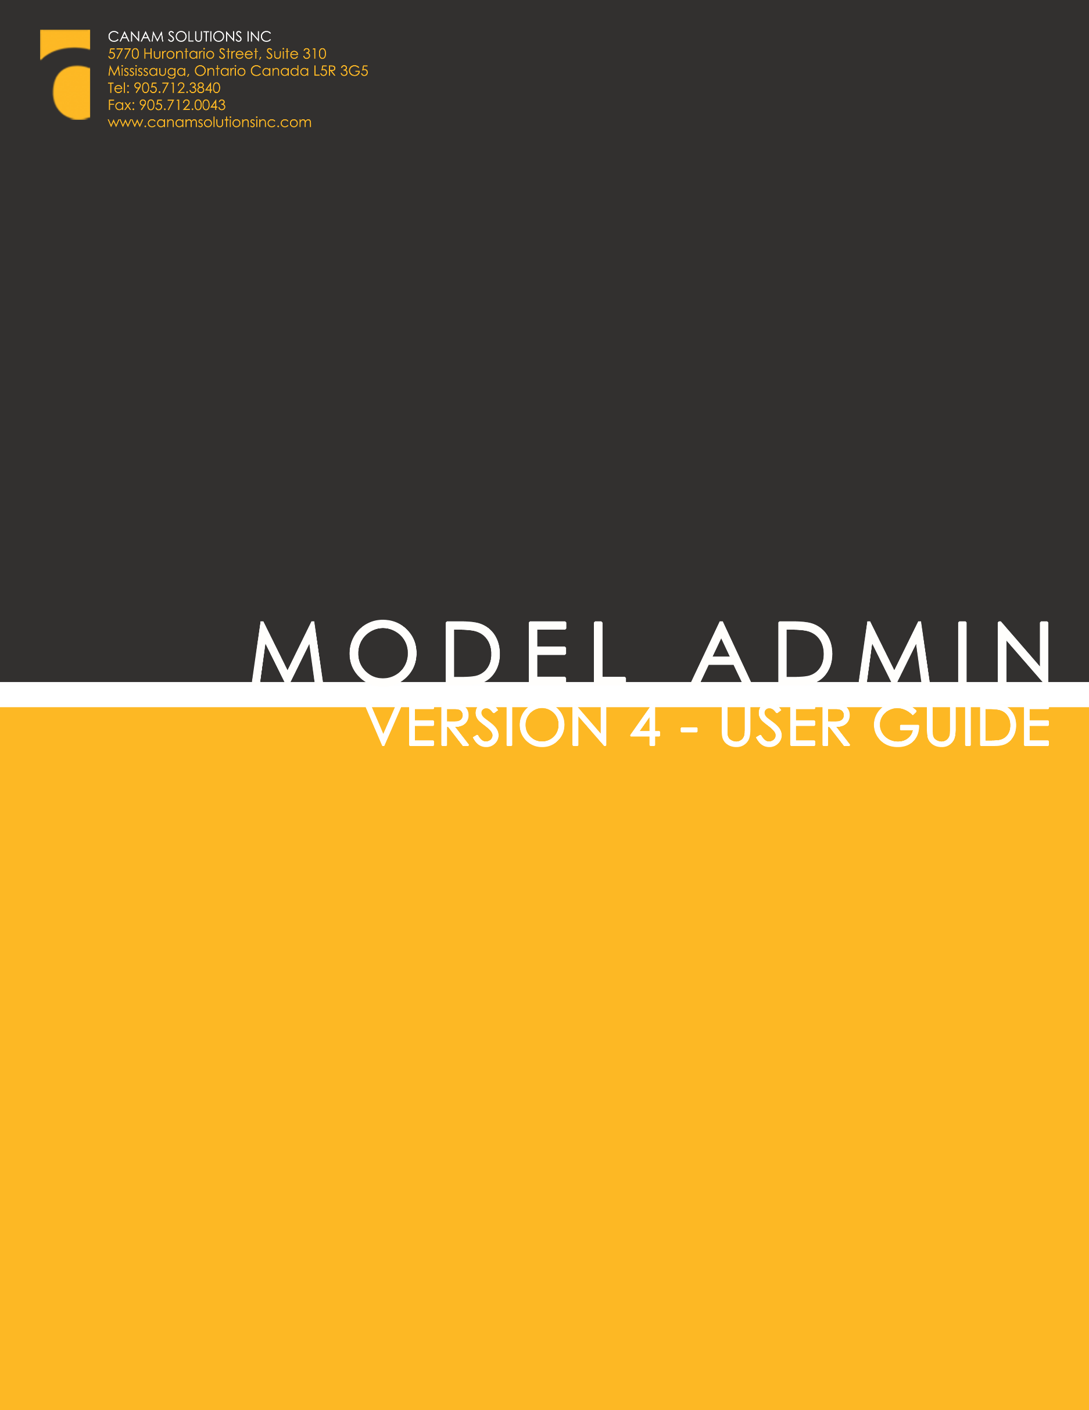

Disclaimer
Unless otherwise specifically stated, the copyrighted information contained herein is made available to licensed dealers by Canam Solutions Inc. for use as a guideline of software use and procedures. The intent of this document is to assist in training and creating manuals for internal training using the information provided.

Trademarks
All products detailed in this document is property of Canam Solutions Inc. and cannot be used or reproduced by any person or company without a purchased license agreement or, having the written consent of Canam Solutions Inc. Any unauthorized reproduction of product and relating documents are subject to legal action; and is protected by Federal, Provincial and Local law. Any concerns as to the legality of reproduction should be directed to: Canam Solutions Inc. Attn: President at 5770 Hurontario Street, Suite 310 Mississauga, Ontario, Canada. (905) 712-3840.

Model Administration
User Guide
Version 4
March 28, 2016
Contents

Overview 5
Manage The Menu 6
Menu 6
Base Models 6
Manage Warranties 7
Warranty Period 7
Warranty Specifications List 7
Applying Warranties to Models 7
Extended Warranty Upload 8
Extended Warranty Report 10
Preventive Maintenance 12
Preventive Maintenance Specifications 12
Preventive Maintenance Rates Period 12
Manage Users 13

Overview
The Model Administration module is a primary administration tool that drives family and model relationships in several core applications within the Canam portfolio of products. The following applications affected by the tool.

- SalesLink and Customer Search in the product lists
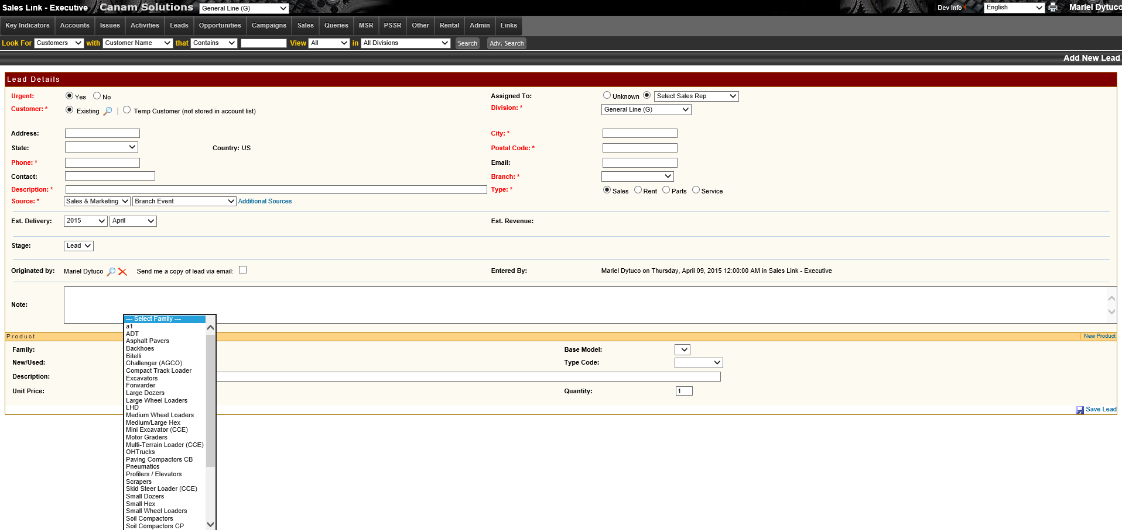
- iQuote Menu
- Product Problem Management (PPM) Menu
- Customer Issue Management (CIM) in the product list
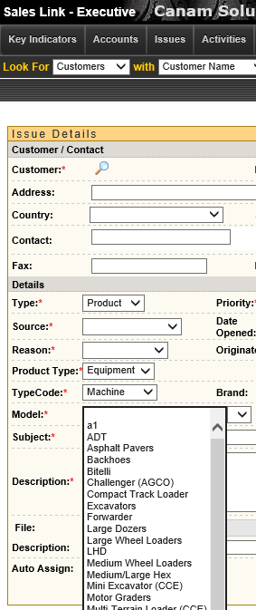

- Commissions Module
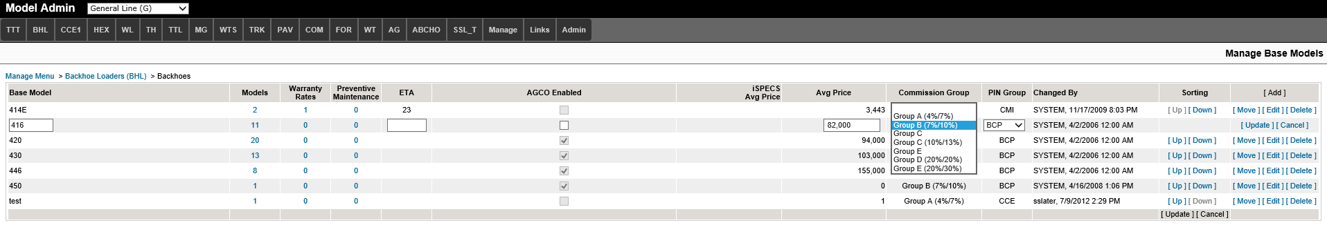
- Customer Order To Invoice (COTI)
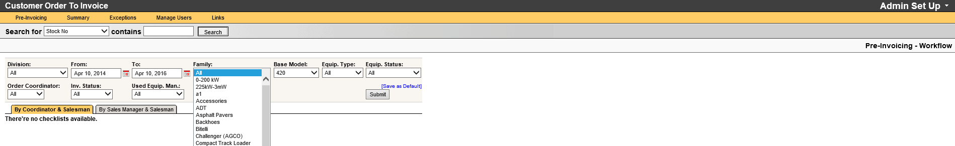

Model Administration hierarchy consists of 4 levels.
- Menu Level Family (TTT, BHL, CCE, HEX etc.)
- Family Sub-Grouping (example, within TTT the family level would be further defined by BCP or Trim Dozers depending on dealer specific naming conventions)
- Primary Base Model (entering the primary base model such as D3)
- Display Model example: D3 XL, D3 XLCab

The system has several unique functions that are specifically orientated to driving functionality in other applications. These specific functions are:
- Warranty Rates
- Preventive Maintenance
- Display Model Maintenance
- Commission Groups
- iSpecs Average Price
- PIN Group

Initial Set-Up of Model Administration
The initial load of the Model Administration module is pre-populated with family classes, base models and model detail that may or may not be applicable to an individual dealership. These need to be reviewed and modified according to dealer preferences.

Manage The Menu

Menu
A user will manage the menu items, edit the names of each item or delete it. A dealership may decide to rearrange the order of the menu based on the dealership’s preference or include or exclude models from other applications.
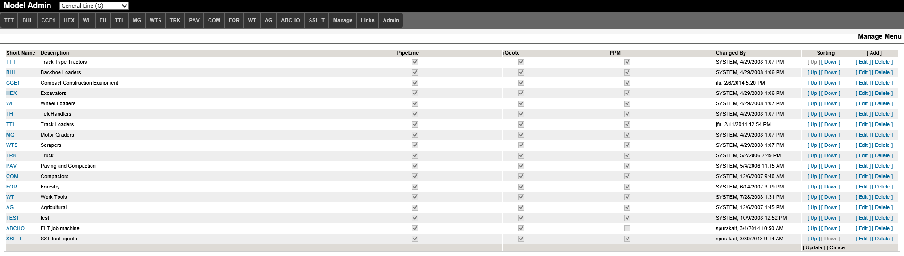

If rearranging the menu, select the ‘up’ or ‘down’ links to the right of the item and it will move accordingly. The changes will be indicated with a red asterisks and that will also indicate that the changes have not been saved. Select ‘Update’ on the bottom of the sorting column to save the changed.

Base Models
This page shows an overview of all the primary base models and display models in the application in the specific division chosen in the top drop down.

The fields that are visible in the dealerships’ environment may differ depending on which additional applications are licensed and/or enabled.
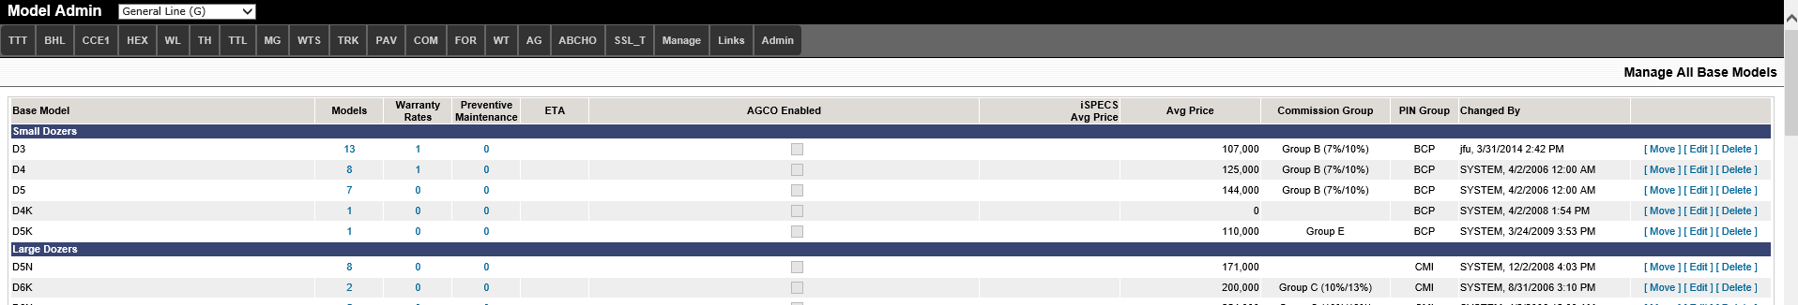

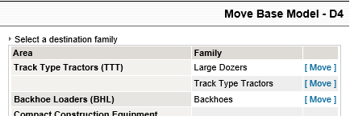
If you choose to move a model from one base to another, select the ‘Move’ link to the right of the model and choose ‘Move’ beside the area/family to move the base model to.

Manage Warranties
There are two methods to associating warranties with models, manually or uploaded.

Warranty Period
The system will use the warranties in the current period. Active period are warranties that are still available and will show as options in iQuote;
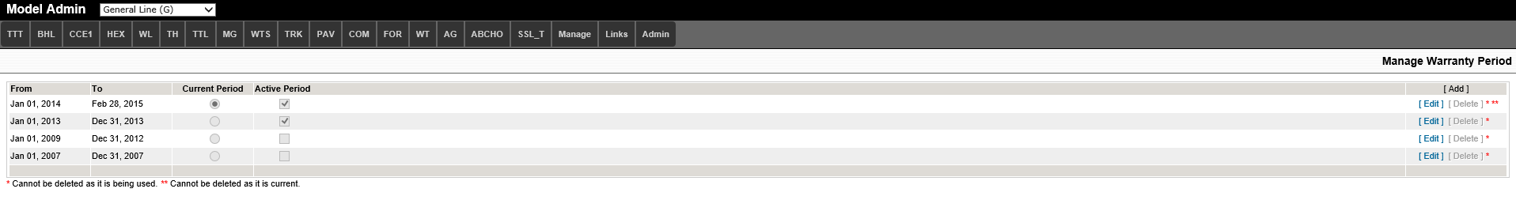
Once the ‘To’ date is reached, the user has the option of extending the date if the current warranties are still valid or creating a new period. The new period requires warranties to be applied to models again.
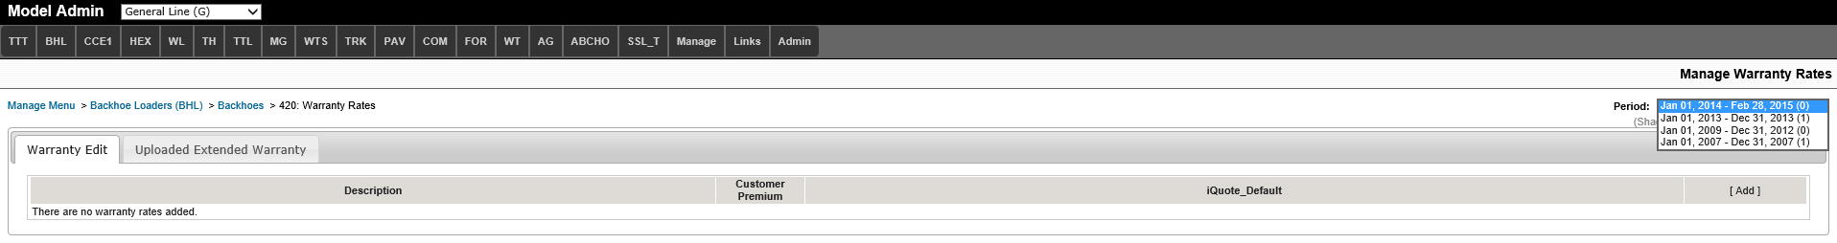

Warranty Specifications List
To manage the list of warranties that are found in the drop down list when manually adding a warranty, the user would go to the ‘Manage’ menu and then ‘Warranty Specifications’.
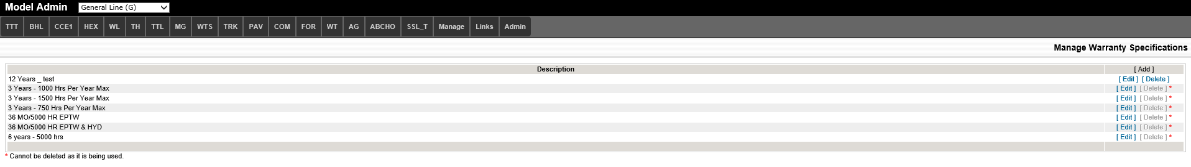
To manually add a warranty to a model to the current period, select from the drop down list, enter a premium and select ‘Add’.
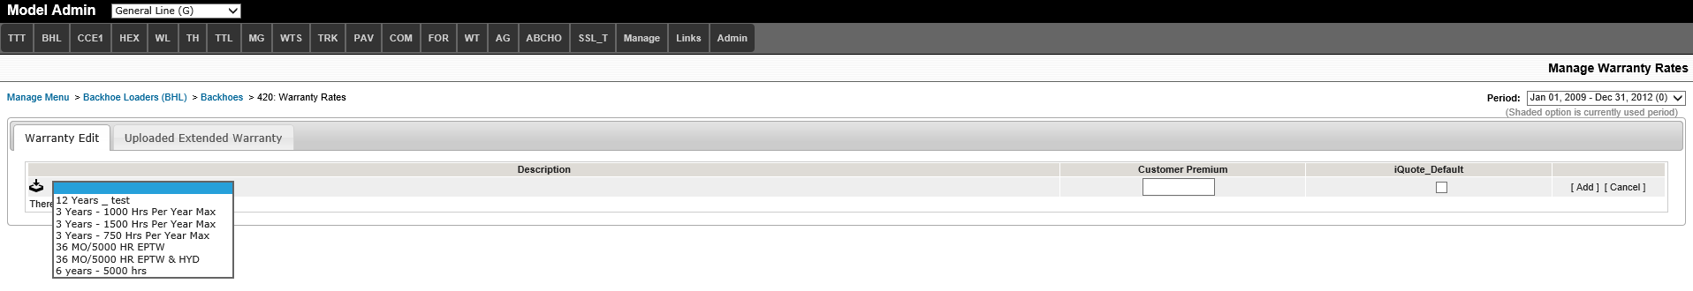
Changing the period will also show warranties that have been added to previous periods.

Extended Warranty Upload
Before the first upload, the server needs to be updated. Provide the following information to your IT dept.

- Install Visual Studio 2010 Tools for Office Runtime and 2007 Office System Driver (Data Connectivity Components) on the Web Server where Model Administrator is located. Canam won’t install it, so you need to check with your IT department.

  - You can find the link to install these tools on:
    - Visual Studio 2010 Tools for Office Runtime: http://www.microsoft.com/download/en/details.aspx?id=13255
    - 2007 Office System Driver (Data Connectivity Components): http://www.microsoft.com/download/en/confirmation.aspx?id=23734

The data provided by CAT in excel format can be uploaded into Model Administration. The following columns are required in the spreadsheet to be loaded:
- Caterpillar
- New Equipment Protection Plan
- Dealer Code
- FAMILY
- MODEL
- Please Read
- CATEGORY
- Coverage Start
- Parts Reimbursement at DN Plus
- MONTHS
- HOURS
- Coverage Type
- Coverage Price
- Fin Merch Pgm
- Dealer Price
- CURRENCY
- Customized Coverage Code
- Effective Date
- Expiration Date
- Date Published

Important notes:
- You need to make sure all the columns above exist and have the same name.
- The file can have more columns than listed above but only data from the columns above will be imported.
- The maximum file size for upload is 10MB.
- The file can have multiple excel sheets but the maximum records for each sheet is 11000 records.
- The family name needs to be between brackets (), like MINI EXCAVATORS:
HEXMN (MINI EXCAVATORS) or (MINI EXCAVATORS)
- Only models and families that exist on Model Administrator will be valid to upload.
- Only one tab per Excel file
- Some models and families may have ‘_T4’ on its name. You don’t need to remove it because the logic will ignore the ‘_T4’.
- The system will not duplicate warranties if the same file is loaded more than once

Upload a Warranty file
Step 1: Select Applicable Period
If the period that the warranties are valid is not set up yet, set up the period by going to ‘Manage’ then ‘Warranty Period’
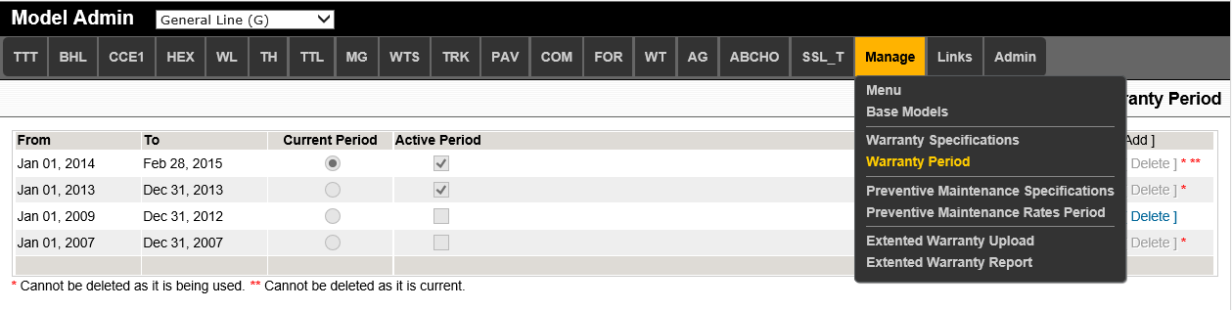
Step 2: Download the File
Download the warranty list from CAT file by going to ‘Manage’ then ‘Extended Warranty Upload’.
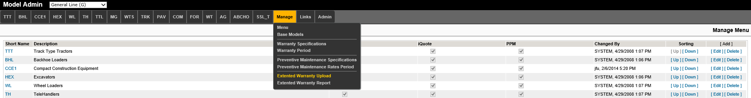
Select the period added on step 1 and then browse for the xls file. Click on button ‘Upload’.

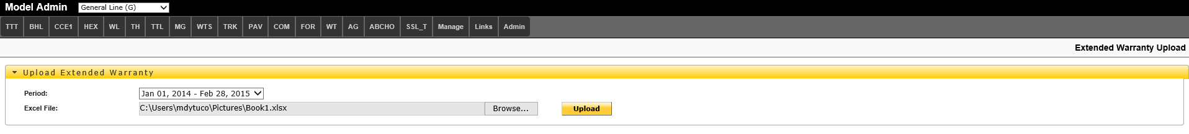
Step 3: Validation
After the file is loaded, a validation summary will be displayed. It shows the list of data that will be imported and the list of exceptions. The user can go through the exceptions and check if any data needs to be change on the excel file before the data is imported.
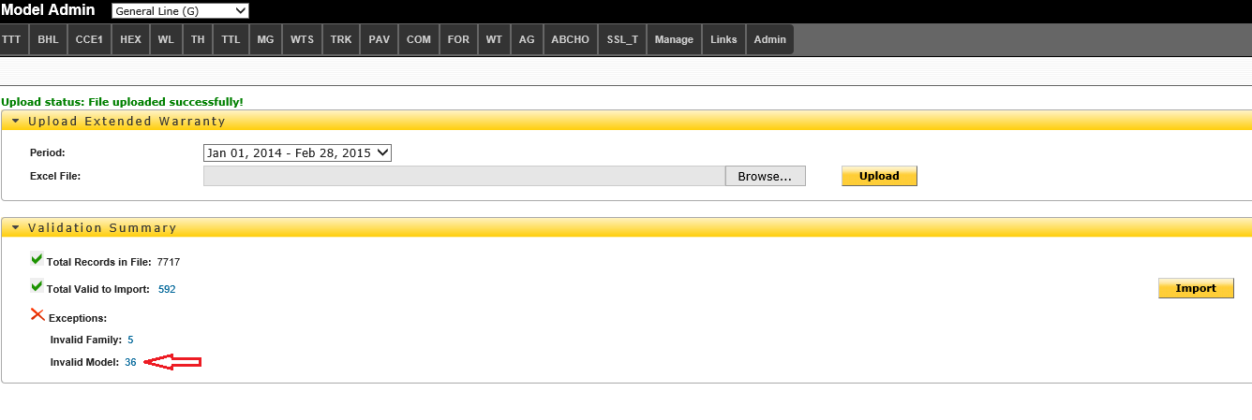
Select the blue number to see beside ‘Total Valid to Import’ to view the report as shown below.
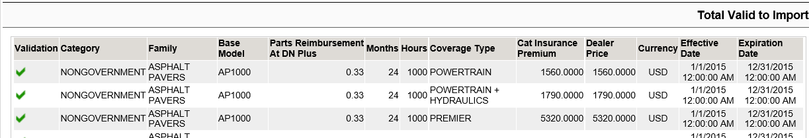

Below is an example of an ‘Exception’ report for ‘Invalid Model’.
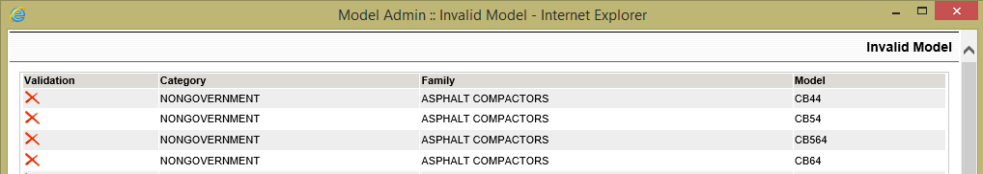

Step 5: the admin can choose to add the models Click on Import to start importing the valid data.

The admin can choose to create the families and / or base models that were invalid. The file will need to be reloaded to import the data for the newly created items. The system will not duplicate the warranties if the same file is loaded. If the same file is loaded, values will be replaced with the new ones.

Extended Warranty Report
After the data is imported a report page is displayed with all the data imported. This report also can be accessible from top menu Manage then Extended Warranty Report item.
The table should be viewed as a cross reference based on:
- Base Model
- Model
- Months
- Coverage Type
- Number of Hours
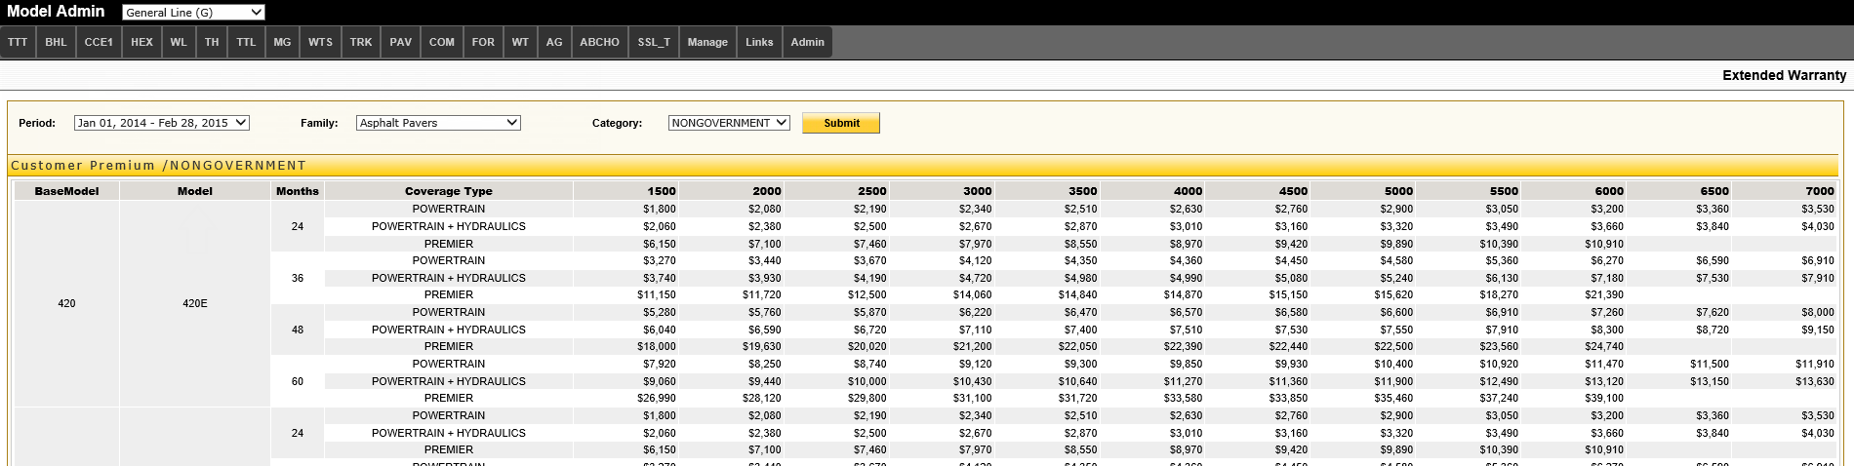

Upload Extended Warranty tab shows the list of warranties that were imported for that Base Model. This is a report and nothing can be edited.

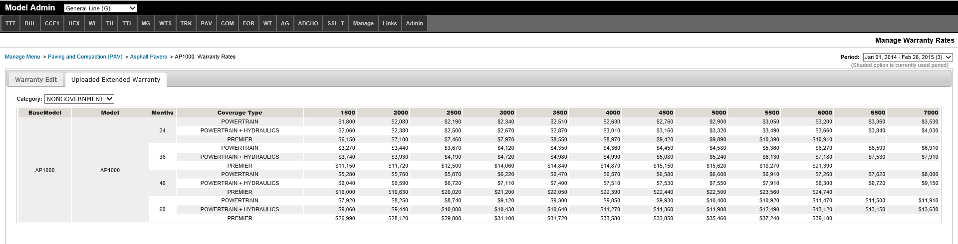

Applying Warranties to Models
Go to Base Model and select number in the warranty column. A list of applied warranties will show on the screen. 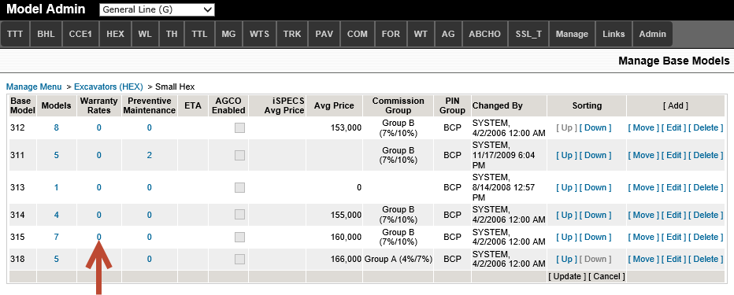

The user will be able to edit/remove these warranties or add new ones. The manually added warranties added appear with the user icon while the imported warranties will show the download icon. In either type, the premium amount can be edited and only one iQuote default can be chosen from the list.

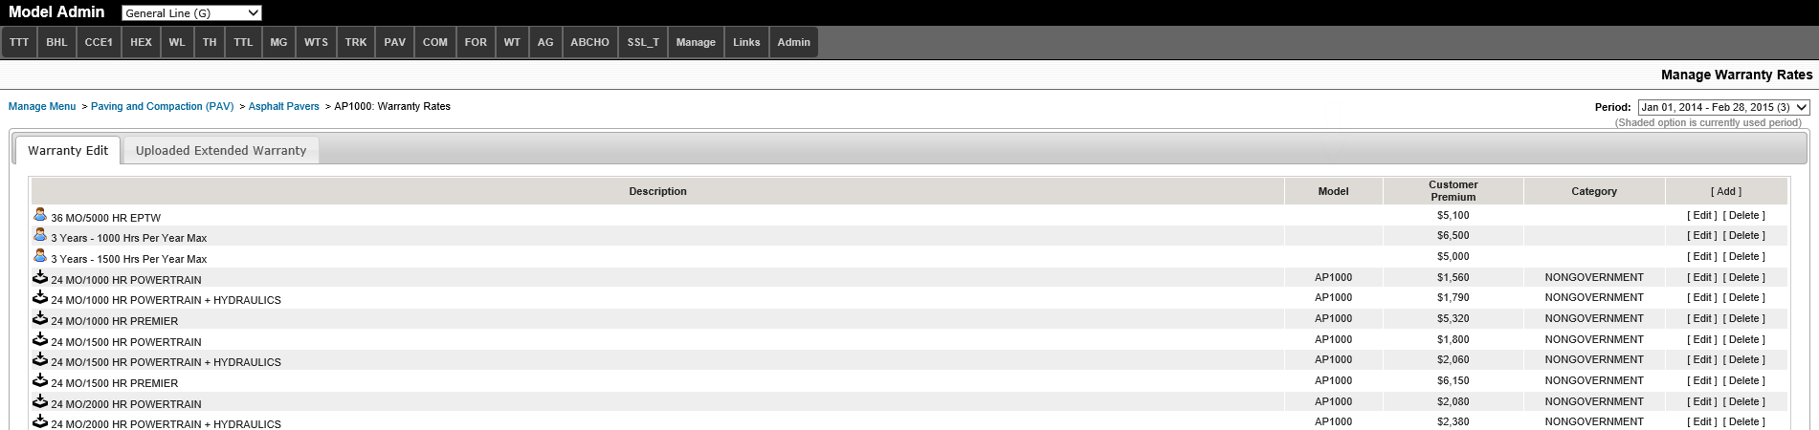

Preventive Maintenance
The PMs will appear in the CSA section of every quote created in iQuote.

Preventive Maintenance Specifications
In the ‘Manage’ menu, enter new or change existing descriptions for the PMs on the ‘Preventive Maintenance Specifications’ page.
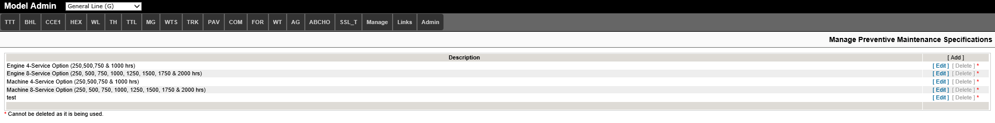

Preventive Maintenance Rates Period
In the ‘Manage’ menu, the ‘Preventive Maintenance Rates Period’ control the date ranges that the PMs should be available in iQuote. Once the ‘To’ date is reached, the user has the option of extending the date if the current PMs are still valid or creating a new period. The new period requires PMs to be applied to models again.
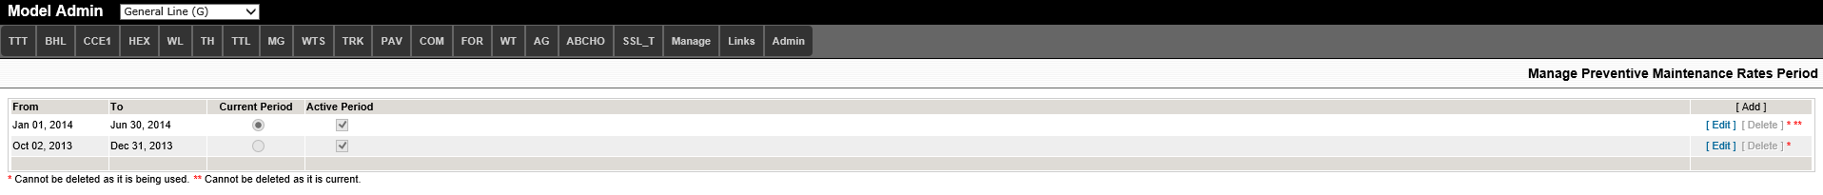

Applying Preventive Maintenance to Models
Go to Base Model and select number in the preventive maintenance column. A list of applied PMs will show on the screen.

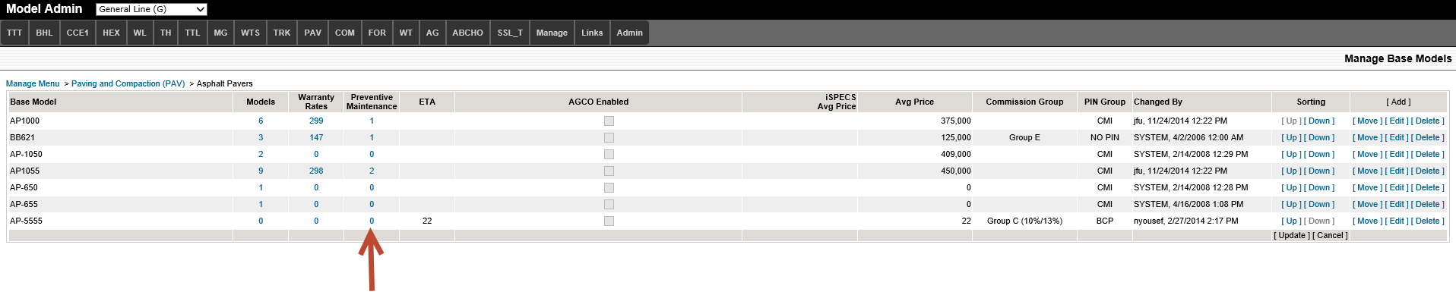
Select Add, choose the PM description from the list and the dollar amount for each PM. The customer premium with be a total of the four amounts entered.

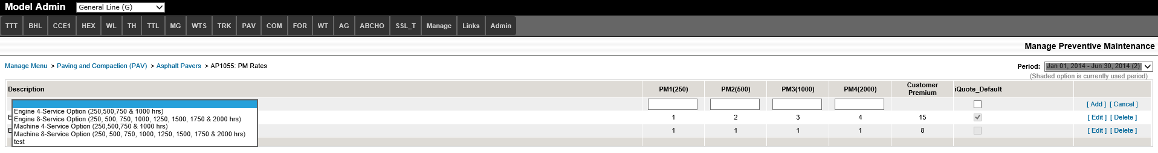

Manage Users
There is only one level of access for Model Administration. If a user is able to access the application, they will be able to perform all functions within the application. The only function that requires specific access is having the ability to grant other users access to the application.

In the Admin menu, select ‘Manage Users’.

Select ‘Add’ to search for the user using their last name. If the user will need the ability to add more users to the application, select the ‘User Admin’ box.

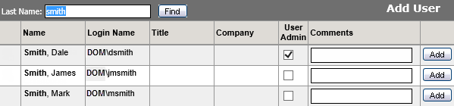
After selecting the ‘Add’ button, the users with ‘User Admin’ rights will be indicated with icon

To remove access, select the red X in the far right column of the user.
