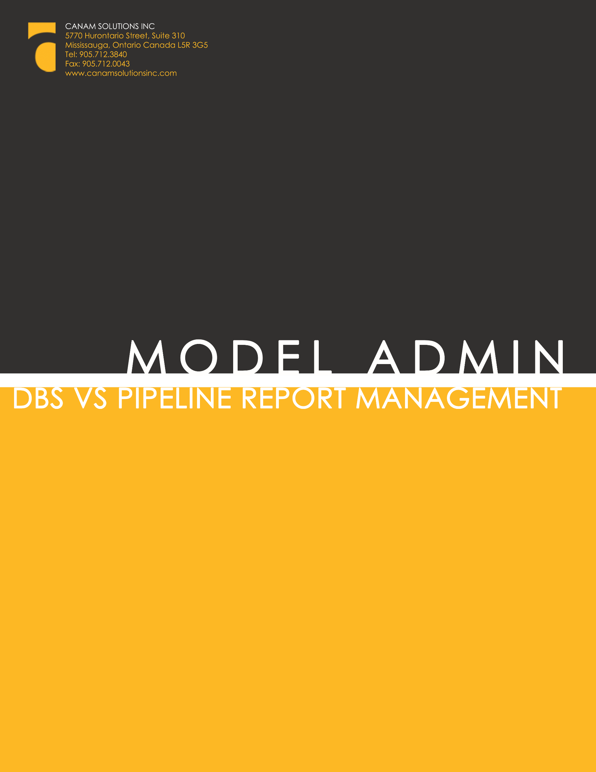

Disclaimer
Unless otherwise specifically stated, the copyrighted information contained herein is made available to licensed dealers by Canam Solutions Inc. for use as a guideline of software use and procedures. The intent of this document is to assist in training and creating manuals for internal training using the information provided.

Trademarks
All products detailed in this document is property of Canam Solutions Inc. and cannot be used or reproduced by any person or company without a purchased license agreement or, having the written consent of Canam Solutions Inc. Any unauthorized reproduction of product and relating documents are subject to legal action; and is protected by Federal, Provincial and Local law. Any concerns as to the legality of reproduction should be directed to: Canam Solutions Inc. Attn: President at 5770 Hurontario Street, Suite 310 Mississauga, Ontario, Canada. (905) 712-3840.

Model Administration
- DBS vs Pipeline Management
Last Update: March 28, 2016

Daily Report Process and Management
The DBS vs Pipeline Report was developed to provide the results of a comparison between equipment added to DBS and what is visible in Model Administration. More than being a workflow tool, this report is for visibility and cross check.
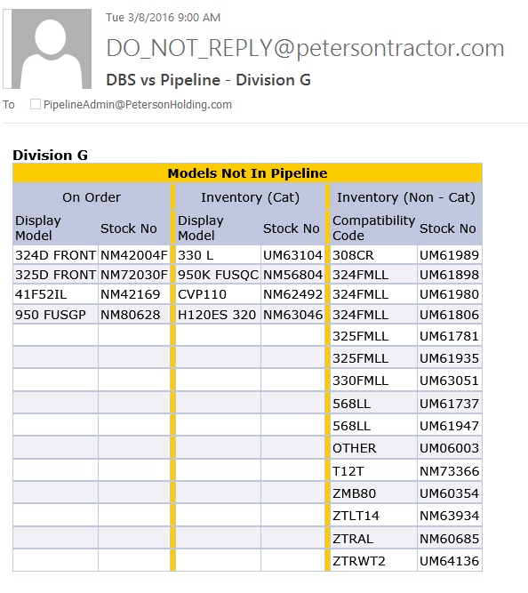

Pipeline (Model Admin), iQuote and DBS have a relationship based on display Model set-up. In order for iQuote to see New CAT (AA) or New AGCO inventory, display Model nomenclature must be entered into Pipeline as it is in DBS. The display Model names are then assoicated with the appropriate family class hierarchy in iQuote (CCE, BHL, HEX, etc) and the units then fall into the appropriate product and base model families.

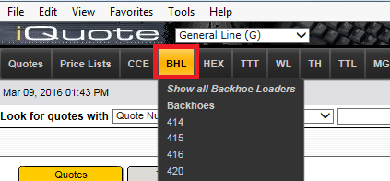

The DBS field used for this display mapping is the MODEL field shown below (MNTEMIEQ). Best Practice is to enter the MODEL as shown on the CAT Price List. It is not recommened that the machine configuration be displayed in the Model field as the integrity of the data will be compromised for other reporting. You can use the ‘Memo’ field in DBS to enter specific configuration options, specifically for Used or Rental Equipment.
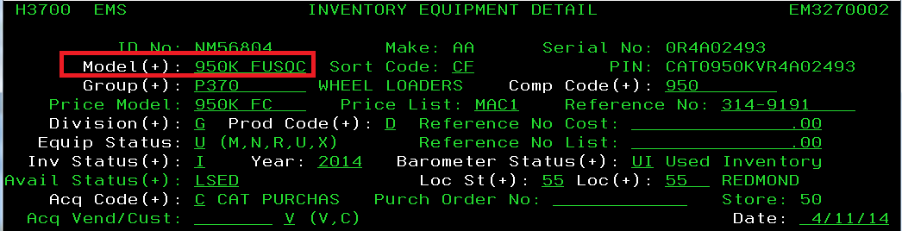

It is important to note that if a model appears on this Exception Report, it is not visible in iQuote and steps will need to be taken to either ‘add’ the new model, or correct the nomenclature in DBS. A separate report is distributed daily for each division (G, K, M, T, E ) and each must be managed if the units are to be quoted through the iQuote application. There are 3 categories of equipment in the report.
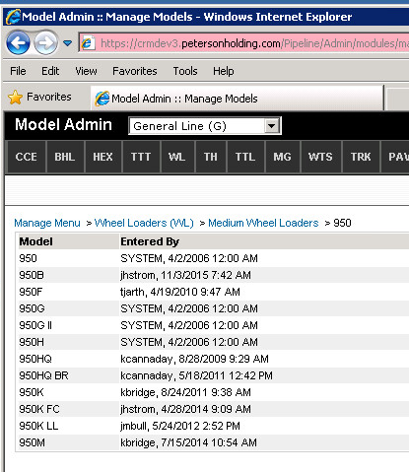

Machines on Order
If an order has been placed and acknowledged in DBS and this model is not present in Model Administration, it will appear in Column 1. If this is a model that you will be quoting in iQuote, or adding to an opportunity in SalesLink, then the administrator will add this model in Model Administration. Once added, the model will drop off the report the next time it runs. In this example, there is no current CAT price list for a 950 FUSGP so a decision needs to be made to either correct the display Model in DBS or to add it to Pipeline. DBS and iQuote reflect only the most current CAT price list models.

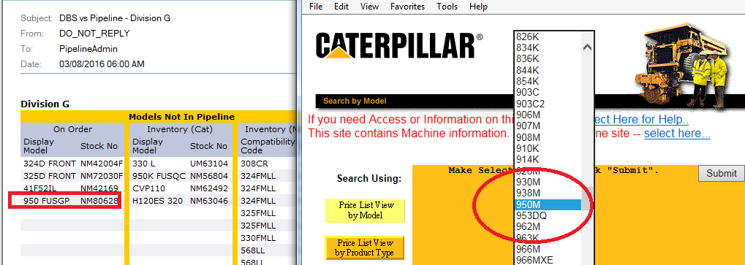

Inventory (Cat)
If a machine has been added to Inventory in DBS and that model does not appear in Model Administration, it will appear in Column 2. As illustrated above, there is no 950K FUSQC in Model Admin. That may mean that the display Model needs to be modified in DBS to match, or you may choose to add the model. Alternatively, you may choose to disregard the model as “one off”, or as an older machine taken in on trade. Keep in mind that if the model is not added in Model Admin, the Sales Rep will not be able to locate it in iQuote and will need to do a manual entry of the quote.

Inventory (Non-Cat)
The differentiator in this column is that iQuote looks at the Compatibility Code in DBS and not the display Model. The logic of iQuote when it comes to competitive equipment is to place that unit in the CAT Product Family that the competitive piece most resembles. So, if you have a JD 5055 model that is MOST similar to a CAT 420 backhoe, you would enter 420 in the Compatibility field in DBS and that unit will appear in the iQuote BHL /420 product line to be quoted.

As an example, UM61980 is a NON CAT unit with a Compatibility Code of 308CR. The Comp Code of 308CR must appear in DBS and Model Admin for the unit to show up in iQuote. Best Practice: to perserve the integrity of our data, it is recommended to use the BASE model of the machine for the Comp Code as these should already be set up in DBS and Model Admin. In this case, 308 would be suggested but as 308CR was a Comp Code selection in DBS it was used. However, it was ADDED to Model Admin as it did not appear in that nomenclature format.

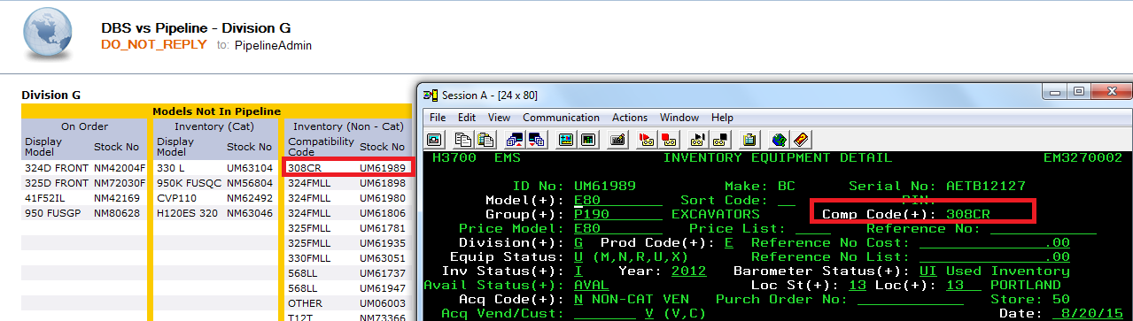

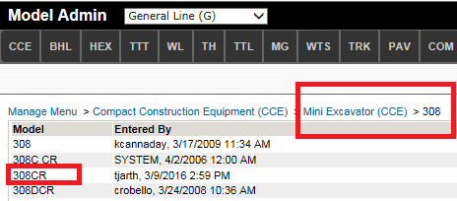
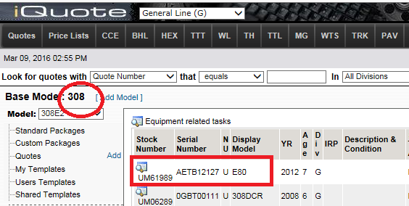

DBS maintains a Compatibility Code Table and if you do not find the Compatibility Code you need in DBS please contact the Data Integrity Team to reivew or add new codes.

