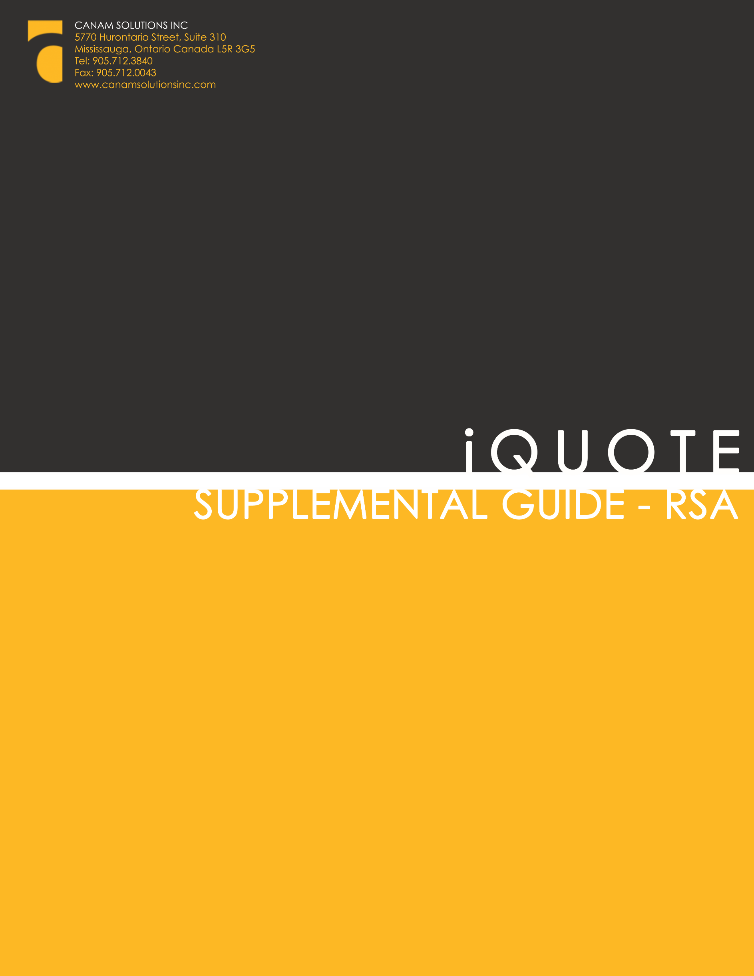
Disclaimer

Unless otherwise specifically stated, the copyrighted information contained herein is made available to licensed dealers by Canam Solutions Inc. for use as a guideline of software use and procedures. The intent of this document is to assist in training and creating manuals for internal training using the information provided.
Trademarks
All products detailed in this document is property of Canam Solutions Inc. and cannot be used or reproduced by any person or company without a purchased license agreement or, having the written consent of Canam Solutions Inc. Any unauthorized reproduction of product and relating documents are subject to legal action; and is protected by Federal, Provincial and Local law. Any concerns as to the legality of reproduction should be directed to: Canam Solutions Inc. Attn: President at 5770 Hurontario Street, Suite 310 Mississauga, Ontario, Canada. (905) 712-3840.

iQuote - RSA
User Guide
Last updated January 28, 2016

Global RSA Set up 5
Add New RSA Program (Admin Method) 6
Editing a RSA Program 7
Set or Change Up RSA % 9
Adding an RSA to a Quote 10
RSA Credit Claim Program Management – Finance: RSA-16-FIN 12

Global RSA Set up
  - Post Sale Credit Claim type of RSA can be added through the Admin menu in the Credit Claims Admin. When the system is updated with RSA, the list below shows the 10+ programs available by % to claim by Area/Family/Base Model/Display Model
  - The name and program numbers and are editable but the claims cannot be deleted.

Claim Number Program Name
RSAClaimNo RSAClaimName
RSA-16-FIN1 Finance - RSA-16-FIN1- program used to calculate and buy down the interest rate
RSA-16-DISC1 Price Discount w/ SURCHARGE - RSA-16-DISC- for price discount, surcharge is calculated and applied.
RSA-16-WTL1 Cat Work Tools - RSA-16-WTL1
RSA-16-EPP1 Cat Extended Warranty: RSA-16-EPP1-pre-populated with values from Configuration page
RSA-16-CSA Cat CSA: RSA-16-CSA- pre-populated with values from Configuration page
RSA-16-TOA1 Trade Over-Allowance: RSA-16-TOA1- allows PSCC up to 10% DN (maximum)
RSA-16-FRR1 First Right of Refusal: RSA-16-FRR1
RSA-16-ST34 RPO or Lease: RSA-16-ST34
RSA-16-CUST1 Customer Credits Option: RSA-16-CUST1
RSA-16-GRAD1 Caterpillar Grading System Program: RSA-16-GRAD1
RSA-16-DISTR1 RSA District Program Example

Add New RSA Program (Admin Method)
  - When adding a new program, RSA Program will appear on the Type list. The remaining fields should be filled out accordingly, this has not changed from the previous versions.

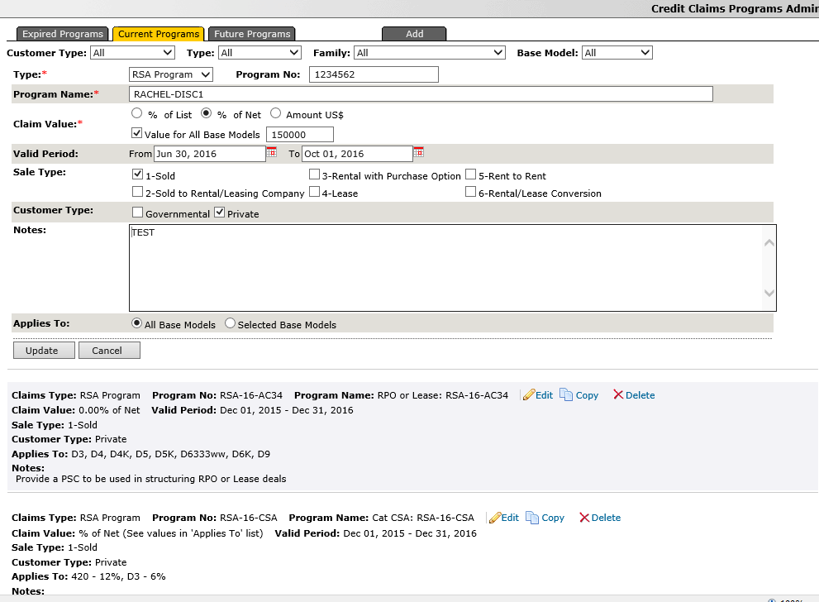
  - To verify if the program has been added successfully, add the program to a quote using the specific models. See Adding a RSA to a Quote below on instructions.

Editing a RSA Program
  - Selecting the Edit icon allows for the information to be edited.
  - If the program only applies to particular models, edit one of the programs and choose the Selected Base Models radio button.
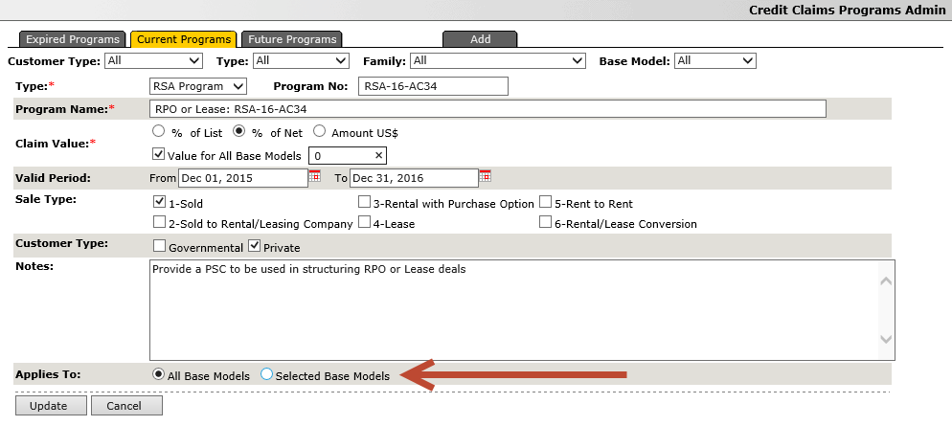
  - Choose a family or individual model the program is applicable to and select Update.
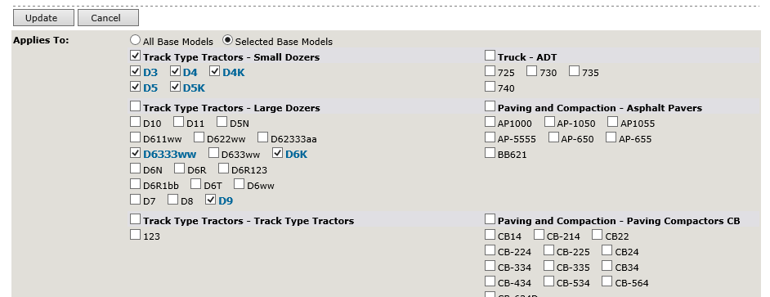

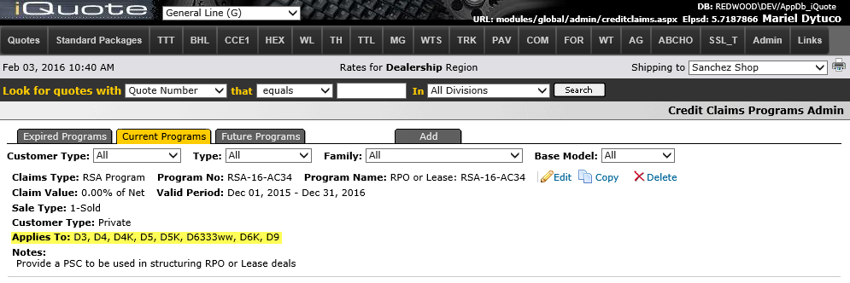

  - To confirm the changes were applied, it should appear on the Credit claims program page.

  - It can also be tested further by checking if the program is available to add to a quote if it applied to that specific model.

  - Confirm calculations are based on the correct formulas and calculations based on the program no.

Set or Change Up RSA %
  - The amount available for RSA will be based on the % of the list/net amount or $ Amount. iQuote will check the three areas ( Area, Base Model, Model ) where the percentage can be configured.
Note: if the percentage is changed, it will only apply to future quotes and will not update on previous ones
  - Area: Changing the percentage at this level will update the percentage for all models in the area

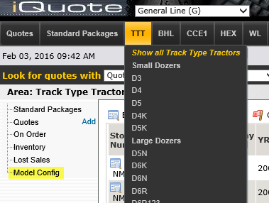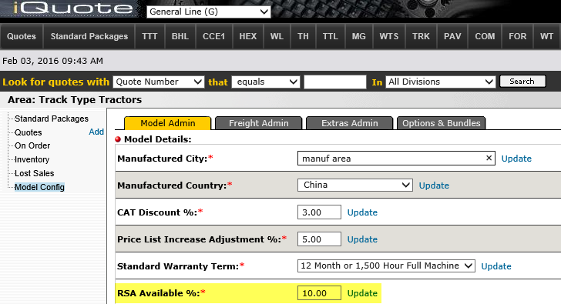
  - Base Model: This number entered will apply to all models within the base model group and replace the amount entered into the Area configuration
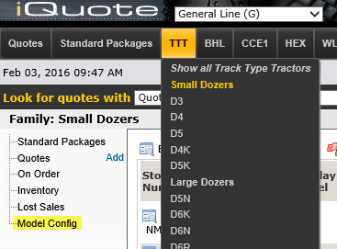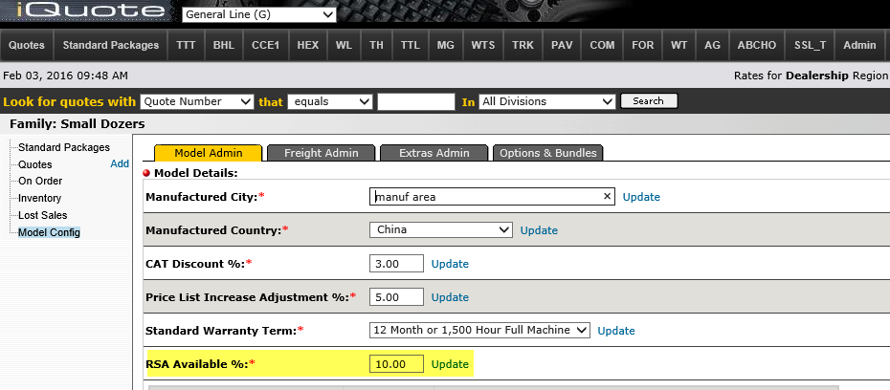

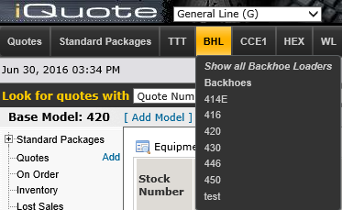
  - Model: This number entered will be used as the percentage for all quotes created for the particular model selected and override the amount entered into the area and base model amount.
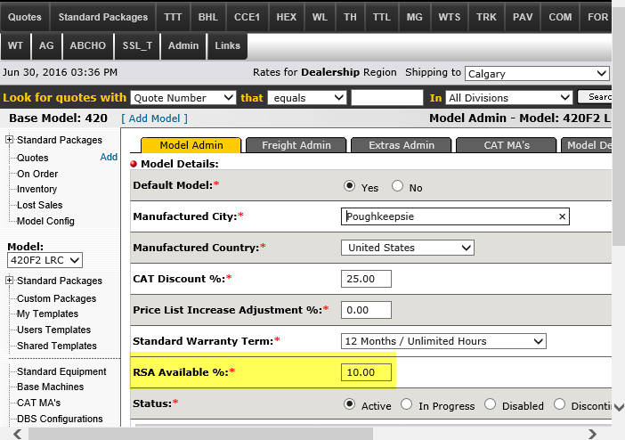

Adding an RSA to a Quote
  - To add an RSA, select edit in the Post Sale Credit Claims section
  - The screen with the RSA programs (both built in and added by admin) will appear.
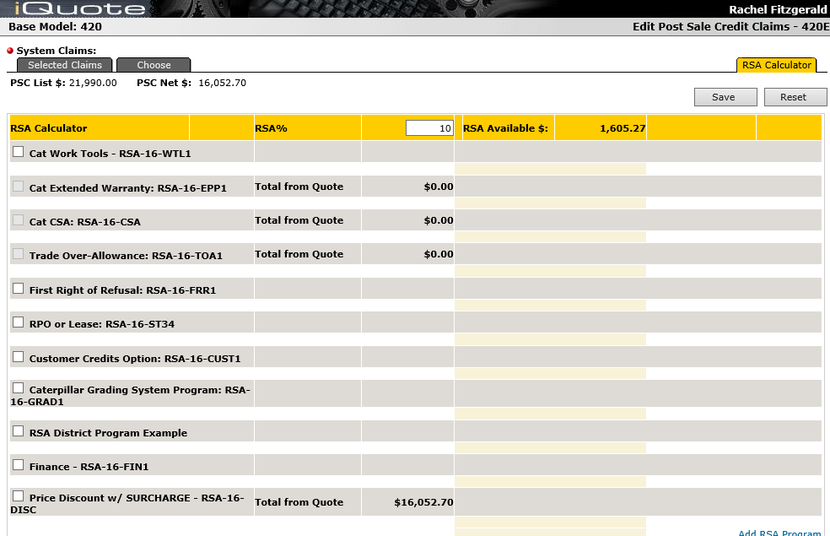
  - The available amount for RSA is based on the Post Sale Credit Claim (PSC) Net which appears on the top right. This amount is derived from the total configurable items amount detailed on the Selected Claims tab. The formula is as follows : RSA Available = PSC Net x RSA %
  - The percentage is set by the admin either at the model, base model or area level (see Set or Change Up RSA %) but can be manually overwritten. RSA % is mapped from iQuote Model Admin
  - If the number is changed, press Save to recalculate the amounts.

RSA Credit Claim Program Management – Finance: RSA-16-FIN
Note: It’s important to note that the configuration should be completed prior to calculating the Finance program
  - The Financial information will be added to the Payment Terms & Taxes > Payment Terms = CSC-RSA (populated fields are un-editable, no other Payment Terms can be added when this program is selected.)
  - This program is used to ‘buy down’ the interest rate, utilizing RSA funds
  - The ‘Edit Finance’ option presents the Payment Terms & Taxes > Finance pop-up screen, enabling the user to add taxes and any other amount pre-or-post tax that’s applicable to the amount to finance.
  - Add Term (months) and Standard Rate % that you would like to buy down
  - If there’s a known subsidy from Caterpillar Finance – add it to the CFSC Subsidy % field
  - If you know the effective rate that you would like – click on the edit pencil and enter the desired rate
  - Be sure to include the Cash with Order if appropriate and click SAVE to calculate both the RSA Subsidy as well as the RSA Used $
